**Semester Management System**

Contents

ABSTRACT 2

Background **Error! Bookmark not defined.**

Definition and Accroynm 3

**Proposed system** 5

Feasibility Report 6

Project Design Description **Error! Bookmark not defined.**

Software Requirements Specifications **Error! Bookmark not defined.**

Hardware Requirements 11**Error! Bookmark not defined.**

Software Requirements **Error! Bookmark not defined.**

Data Flow Diagrams 12

Conclusion **Error! Bookmark not defined.**

Acknowledegment **Error! Bookmark not defined.**

# 

# ABSTRACT

The Semester Management System is a comprehensive software solution designed to streamline and automate various administrative tasks and processes within an educational institution. It serves as a centralized platform for managing student records, faculty information, academic activities, attendance tracking, fee management, and much more. This system aims to enhance efficiency, improve communication, and provide valuable insights for effective decision-making in the Semester administration.

**Introduction**

The Semester Management System is an advanced software application developed to simplify and optimize the day-to-day operations of educational institutions. With the increasing complexity of administrative tasks in Semesters, the need for an integrated system that handles diverse functions has become crucial. This system provides a user-friendly interface that empowers Semester administrators, teachers, students, and parents with efficient tools and resources to enhance productivity and streamline operations.

The primary objective of the Semester Management System is to digitize and automate the traditional manual processes involved in managing student information, academic records, and administrative tasks. By leveraging technology, this system enables Semesters to effectively manage their resources, maintain accurate records, and foster a collaborative environment between stakeholders.

Key features of the Semester Management System include:

1. Student Information Management: The system allows administrators to maintain comprehensive student profiles, including personal details, academic records, attendance history, and disciplinary records. It facilitates easy access to student information, simplifying tasks such as admissions, transfers, and generating reports.
2. Faculty and Staff Management: This module enables Semesters to manage their teaching and non-teaching staff efficiently. It includes features for maintaining faculty profiles, managing timetables, assigning responsibilities, and tracking attendance. It also simplifies payroll management and provides a platform for effective communication between staff members.
3. Attendance Tracking: The system automates attendance tracking for both students and staff, reducing manual efforts and improving accuracy. It enables real-time monitoring of attendance records, generates attendance reports, and sends notifications to parents in case of absenteeism.
4. Academic Management: This component facilitates effective management of academic activities, including curriculum planning, timetable creation, and exam management. It assists in generating progress reports, calculating grades, and tracking student performance. Teachers can also use the system to upload assignments, share study materials, and communicate with students and parents.

In conclusion, the Semester Management System is a powerful tool that revolutionizes the way educational institutions manage their operations. By automating administrative tasks, enhancing communication, and providing valuable insights, this system empowers Semesters to deliver a more efficient, organized, and student-centric educational experience.

**DEFINITIONS AND ACRONYMS**

* GUI - GUI stands for Graphical User Interface. It refers to the visual interface that allows users to interact with software applications using graphical elements such as buttons, menus, and windows. In the context of the project, the GUI provides a user-friendly interface for the Royal Casino Java application.
* Java - Java is a widely used object-oriented programming language known for its platform independence. It is used in this project to develop the Royal Casino application.
* JFrame - JFrame is a class in Java's Swing library that represents a window or frame for building graphical user interfaces. It provides features for creating and managing windows, handling user events, and displaying graphical component
* **java.sql.\***:
  + Definition: The **java.sql** package provides classes and interfaces for accessing and manipulating data in a database using SQL (Structured Query Language).
  + Acronym expansion: SQL stands for Structured Query Language, which is a standard language for managing relational databases.
* **java.text.SimpleDateFormat**:
  + Definition: The **SimpleDateFormat** class is a part of the **java.text** package and is used to format and parse dates according to a specified pattern.
  + Acronym expansion: None (This import does not have a specific acronym associated with it).
* **java.util.logging.Level** and **java.util.logging.Logger**:
  + Definition: The **java.util.logging** package provides a flexible logging framework for Java applications. The **Level** class represents the logging severity levels, and the **Logger** class is used for logging messages.
  + Acronym expansion: None (These imports do not have specific acronyms associated with them).
* **javax.swing.JOptionPane**:
  + Definition: The **javax.swing** package provides classes for creating graphical user interfaces (GUI) in Java. The **JOptionPane** class is a part of Swing and provides standard dialog boxes for displaying messages, getting user input, and showing confirmation dialogs.
  + Acronym expansion: None (This import does not have a specific acronym associated with it).

**PROPOSED SYSTEM**

The proposed Semester Management System is a comprehensive software solution designed to automate and streamline various administrative and academic processes within a Semester. It aims to provide an integrated platform that facilitates efficient management of student information, faculty details, attendance tracking, academic activities, fee management, and communication between stakeholders. The system will empower administrators, teachers, students, and parents with tools and features to enhance productivity, collaboration, and data-driven decision-making.

Key Features and Functionality:

1. Student Information Management:
   * Maintain comprehensive student profiles with personal details, academic records, attendance history, and disciplinary records.
   * Track student admissions, transfers, and generate reports.

.

1. Faculty and Staff Management:
   * Maintain faculty profiles, including qualifications, experience, and contact details.
   * Manage teaching assignments, class schedules, and leave records.
2. Attendance Tracking:
   * Capture student and staff attendance electronically using manual entry.
   * Generate real-time attendance reports and notifications for absenteeism.

.

1. Academic Management:
   * Create and manage class schedules, subject assignments, and exam timetables.
   * Record and analyze student grades, generate progress reports, and transcripts.
   * .
2. Reporting and Analytics:
   * Generate comprehensive reports on various aspects like attendance, academic performance, finances, and more.
   * Provide data visualization tools and analytics dashboards for informed decision-making.
   * Support integration with business intelligence tools for advanced data analysis.
3. Security and Access Control:
   * Implement role-based access control to ensure data privacy and security.
   * Encrypt sensitive information and implement secure authentication mechanisms.
   * Regularly backup data and implement disaster recovery measures.

The proposed Semester Management System will offer a user-friendly interface, scalability, and customization options to meet the specific needs of the Semester. By automating manual processes, improving data accuracy, and fostering effective communication, the system will enhance administrative efficiency, student performance monitoring, and parent engagement.

**FESAIBILITY REPORT**

## GENERAL REQUIREMENT FEASIBILITY REPORT

A Semester management system is a software application that is designed to streamline various administrative tasks in a Semester, such as attendance tracking, student information management, grade reporting, and communication with parents and teachers. When evaluating the feasibility of a Semester management system, there are several key factors to consider, including:

1. Needs assessment: Before implementing a Semester management system, it is important to identify the specific needs of the Semester and its stakeholders. This can be accomplished by conducting interviews, surveys, and focus groups with students, teachers, parents, and administrators.
2. Technical requirements: A Semester management system typically requires a robust IT infrastructure, including high-speed internet connectivity, secure data storage, and backup solutions. It is important to evaluate the Semester's existing IT infrastructure and determine if additional resources or upgrades are needed to support the new system.

## PROBLEMS IN CURRENT SYSTEM

The academic achievement for many students has decline, because of lake of care of them from their parents, and this refer to that their parents do not have a free time to come to Semester. Headmasters and Teachers are facing problems at the start of every new academic year, because of distribution process for courses and classes, in addition to this, through and at the end of every year another problem is facing them, which is the complexities of the grade’s entry process for their students. Lack of communication after a Semester day between Headmasters, Teachers, and Students, which has a bad reflection on the educational process.

TECHNICAL FEASIBILITY & TECHNICAL DESCRIPTION

A Semester management system is a software application designed to streamline and automate various administrative tasks within educational institutions. Its technical feasibility depends on several factors, including the availability of technology infrastructure, software development expertise, and integration capabilities with existing systems.

From a technical perspective, a Semester management system typically comprises several modules or components, each serving a specific function. Some common modules include:

1. Student Information System: This module manages student data, including personal information, enrollment details, attendance, grades, and academic progress.
2. Teacher and Staff Management: This module handles teacher and staff information, including personal details, qualifications, schedules, and payroll.
3. Attendance Management: This module tracks student and staff attendance, using methods such as biometric systems, card readers, or manual entry.
4. Examination and Grading: This module manages the examination process, including scheduling, question paper generation, grading, and report generation.
5. Timetable Management: This module creates and manages class schedules, ensuring optimal utilization of resources and avoiding conflicts.

The technical implementation of a Semester management system involves database design and development, user interface design, backend programming, security implementation, and integration with other systems (if required). Technologies commonly used for such systems include web development frameworks, databases (e.g., MySQL, PostgreSQL), programming languages (e.g., Java, Python), and cloud services.

It's important to note that the specific technical details and feasibility of a Semester management system may vary depending on the requirements, scale, and complexity of the educational institution. A thorough analysis of the existing infrastructure and technical capabilities is necessary to determine the feasibility and choose appropriate technologies for implementation.

## GRAPHICAL USER INTERFACE

Student Management System Java application incorporates a graphical user interface (GUI) to enhance the user experience and provide an interactive platform for Admin, Teachers and Students. The GUI elements are designed to be visually appealing and user-friendly, contributing to an easy to maneuver environment.

The graphical user interface (GUI) of the Student Management System Java application is designed to provide an interactive and visually appealing interface for players. The GUI enhances the user experience by offering intuitive controls and visually engaging elements.

**PROJECT DESIGN DESCRIPTION**

Prototyping Model has been used to develop this application. The Prototyping model is a technique for quickly building a function but incomplete model of the information system. There are several kinds of prototypes, but they all intend to reduce risk by building a quick and dirty replica or mockup of the intended system. It can be used to demonstrate technical feasibility when the technical risk is high. It can also be used to better understand and elicit user requirements. In either case, the goal is to reduce risk and limit costs by increasing understanding of proposed solutions before committing more resources.

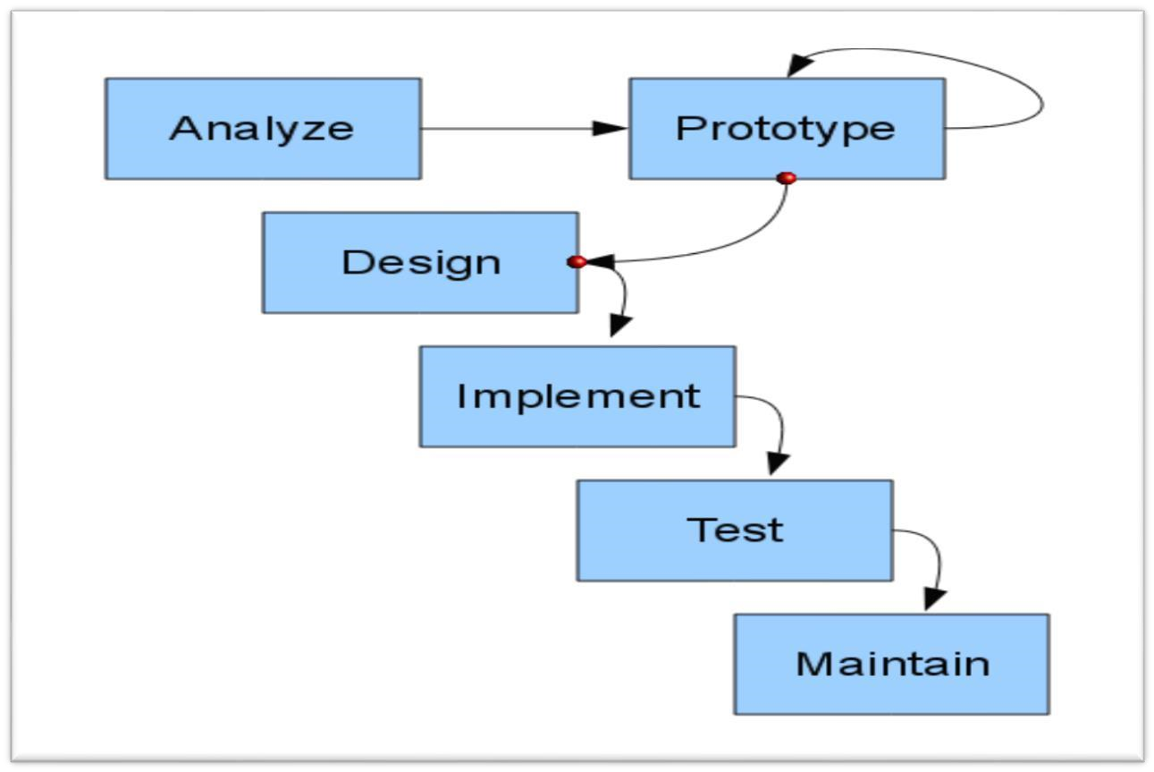

**- Identify basic requirement:** Determine basic requirements including the input and output information desired. Details, such us security, can typically be ignored.

**-Develop initial prototype:** The initial prototype is developed that includes only user interfaces.

**-Review:** The customers, end-users, examine the prototype and provide feedback on additions or changes.

**-Revise and enhancing the prototype:** Using the feedback, both the specifications and the prototype can be improved.

This method involves a series of iterations and refinement until the prototype product is a fully working system, and the user is satisfied.

### PURPOSE

* Users are actively involved in the development.
* Since in this methodology a working model of the system is provided, the users get a better understanding of the system being developed.
* Errors can be detected much earlier.
* Quicker user feedback is available leading to better solutions.
* Missing functionality can be identified easily.
* Confusing or difficult functions can be identified requirements validation, quick implementation of incomplete, but functional application.

**SOFTWARE REQUIREMENT SPECIFICATION:**

The software requirements for the Royal Casino Java application are as follows:

**Requirement Hardware:**

* A computer or device capable of running Java applications.
* Sufficient RAM and processing power to handle the application's execution.

**Requirement Software:**

* Java Development Kit (JDK) installed.
* Java Swing library for GUI development.
* An integrated development environment (IDE) such as Eclipse or IntelliJ IDEA for code development and execution.

These software requirements are necessary for developing, compiling, and running the Royal Casino Java application successfully.

Note: It is important to note that the given code and project information have certain limitations and may not cover all aspects of a comprehensive project. The provided content is based on the available information and may require further customization and refinement based on specific project requirements and objectives.

# DATA FLOW DIAGRAM:

**CONCLUSION**

In conclusion, the Semester Management System based on a GUI in Java offers a comprehensive solution to streamline and automate various administrative and academic tasks within a Semester. By leveraging a user-friendly graphical interface, the system enables efficient management of student information, faculty details, attendance tracking, academic activities, fee management, and communication among stakeholders.

The GUI-based design enhances usability and accessibility, allowing administrators, teachers, students, and parents to interact with the system intuitively. The personalized dashboards, role-based authentication, and secure access control ensure that users can access and manage relevant information based on their roles and permissions.

Through features like student information management, faculty and staff management, attendance tracking, and academic management, the system simplifies routine administrative tasks, improves data accuracy, and facilitates effective communication and collaboration. The integration of fee and finance management ensures efficient fee collection and financial tracking, while the reporting and analytics capabilities provide valuable insights for informed decision-making.

The system's GUI design focuses on providing a visually appealing and user-friendly interface using Java's Swing or JavaFX framework. The design principles of consistency, responsiveness, and ease of use contribute to an enhanced user experience.

Overall, the Semester Management System based on a GUI in Java optimizes operational efficiency, promotes effective communication, and empowers stakeholders with tools for data-driven decision-making. By automating manual processes and centralizing information, the system contributes to a well-organized and productive Semester environment.

**ACKNOWLEDGEMENT LETTER : )**

We would like to express our heartfelt appreciation and gratitude to Miss Samina Noureen for her exceptional guidance and support during our study of Object-Oriented Programming (OOP) subject.

Miss Samina Noureen's expertise and dedication to teaching have been instrumental in our understanding of OOP concepts and programming principles. Her ability to explain complex topics in a clear and concise manner has greatly contributed to our learning experience.

We would like to acknowledge Miss Samina Noureen's commitment to our academic growth. Her encouragement and motivation have inspired us to strive for excellence and explore the depths of OOP. Her willingness to address our questions and provide additional assistance outside of class hours has been immensely valuable.

Furthermore, we appreciate the practical exercises and coding assignments that Miss Samina Noureen has provided. These hands-on tasks have not only enhanced our programming skills but also deepened our understanding of real-world applications of OOP.

In conclusion, we extend our sincere thanks to Miss Samina Noureen for her unwavering commitment to our education and growth in the OOP subject. We are truly grateful for the knowledge and skills we have gained under her guidance.

Regards,

Syed Shahnoor Hasan

Muhammad Faizan Raza